

**PollyVC Survey Report**

**Fall 2021**

Prepared by:



Contents

Executive Summary 3

Summary of Data 4

Demographic Information 5

Employee Morale Dimensions 7

Comparisons Between Variables (Internal Benchmarking) 12

Takeaways & Suggestions 14

# Executive Summary

This report summarizes the findings from a company-wide survey assessing employee morale at the PollyVC Corporation. Within the report the reader will find a summary of the data, followed by a list of Takeaways & Suggestions. Inside of the summary of data, there is information regarding the demographics of participants, averages/means of the predictor/creation variables, and compressions between variables deemed statistically significant.

The survey was completed by 233 employees and highlighted the fact that Human Resources (HR) and Marketing needs to improve the many variables that are low in those departments. While there are low variables in said departments, the general employee morale of PollyVC has a more optimistic angle. Overall, the best morale dimensions consisted of high scores in Emotional Engagement, and low scores in Incivility (Climate), Emotional Exhaustion (Burnout), Abusive Supervision, and Job Constraints. Leaving scores that could be better overall in Job Satisfaction and Organizational Commitment. Both of which need improvement to move away from being neutral (neither agreeing nor disagreeing) on said dimensions.

Building on the findings previously stated, HR and Marketing are the departments in which assistance is needed to improve employee morale. Within each, there can be found low scores of Organizational Commitment, Emotional Engagement, and Job Satisfaction. Inversely, there are high scores of Job Constraints (higher in Marketing), Emotional Exhaustion (Burnout), Abusive supervision (higher in Marketing), and Incivility (again higher in Marketing). With that said, the correlations between variables found coincide with these findings. There were positive moderate correlations between Emotional Engagement and Organizational Commitment, and a higher correlation between Incivility and Job constraints. The negative moderate correlation between Emotional Exhaustion (Burnout) and Emotional Engagement also adds to the previous findings.

These findings highlight the overall importance each department makes when assessing employee morale, and hopefully the suggestions and takeaways provided assists PollyVC with higher scores in the future.

# Summary of Data

The purpose of this section is to inform the reader of general demographic information of the employees who participated in the survey, information regarding the averages and differences between the averages, and trends within subgroups of respondents and variables. This is done by going over the demographics such as their age, sex, tenure, and department within the organization. Then going into each Employee morale Dimension, seeing the average scores, and how they differ from each other. After going over the predictor/criterion variables, internal benchmarking is then followed. Within this section, the most meaningful difference between demographics is dissected and analyzed to see differences between departments. It is then followed with the strongest correlations between variables. By the end of this section, the reader should have a greater understanding of the data, what it means, and an urge to know what can be done to fix the problems seen within it.

## Demographic Information

A total of 223 PollyVC employees participated in the survey found in the email from CEO Frank W. Cockrell. The demographic information consists of the participant’s age, sex, tenure, and department within the organization. All information was gathered from the survey respondents own indications to survey questions.

**Age:** The most frequent age of survey respondents was 35 to 44, with those 45 to 64 coming in a distant second.

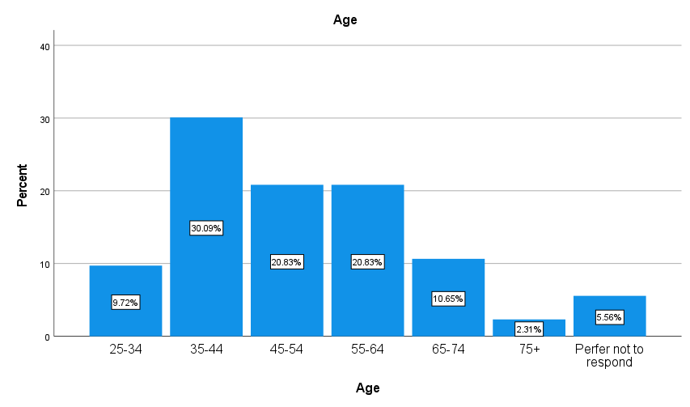

**Sex:** The majority of survey respondents identified as ‘Male’ (54.09%) while 42.27% identified as ‘Female’, with 3.64% preferring not to respond. [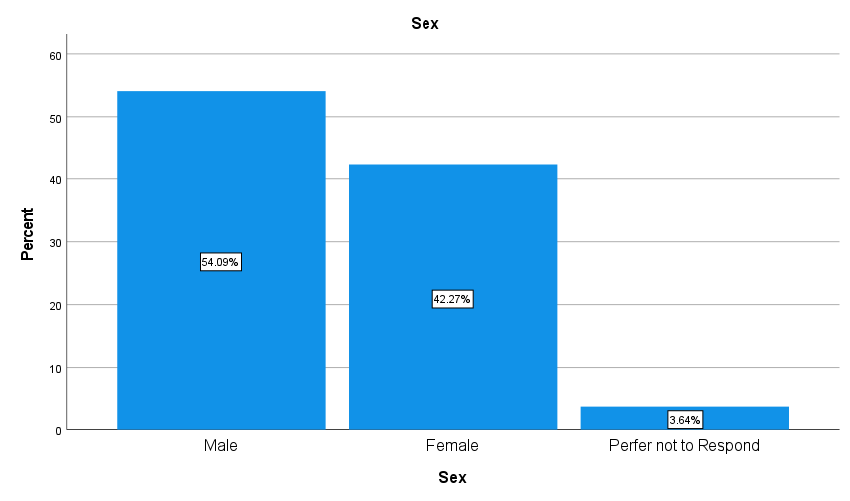](https://www.youtube.com/watch?v=9GZjSYpbn2M&ab_channel=Dr.BakerSDSUMarketing)

**Tenure:** The highest group within tenure had been with the company for more than 20 years (28.70%), the second highest percentage was those who had 1 to 5 years of experience (26.39%).

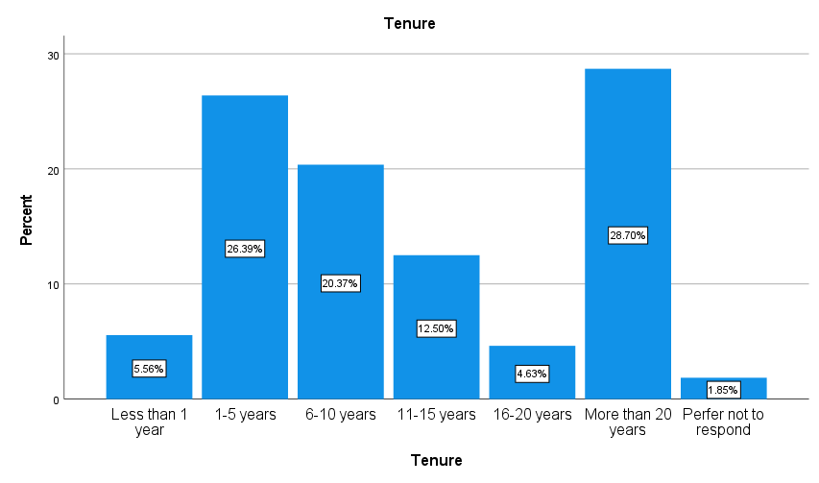

**Department:** The majority of survey respondents were part of the Shipping and Distribution department (36.57%), followed by Billing and Sales (24.54%), Engineering (21.76%), Human Resources (10.65%), and Marketing (6.48%).

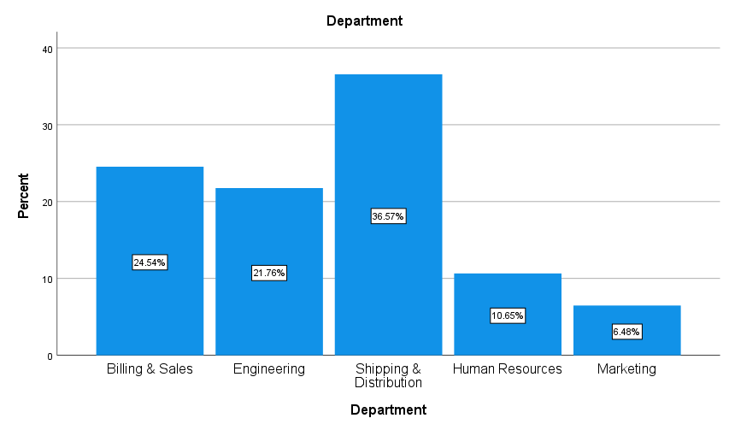

## Employee Morale Dimensions

The variables of employee morale consist of Organizational Commitment, Job Constraints, Emotional Engagement, Emotional exhaustion (Burnout), Abusive Supervision, Incivility (Climate), and Job Satisfaction. The following table is a summary of each dimension, including its mean, standard deviation and its minimum and maximum values. The predictors within this survey consists of job constraints and Abusive Supervision, for the fact that these variables are based solely on their frequency.

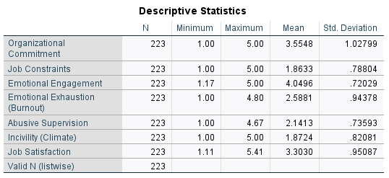

**Organizational commitment:** The average score to this dimension was 3.55, meaning most participants neither agreed nor disagreed with PollyVC having a great deal of personal meaning for them. Participants varied from the average score by one whole point, the most of any dimension. (For clarification, 1=Strongly Disagree, 2=Disagree, 3=Neither Agree nor Disagree, 4=Agree, and 5=Strongly Agree.)

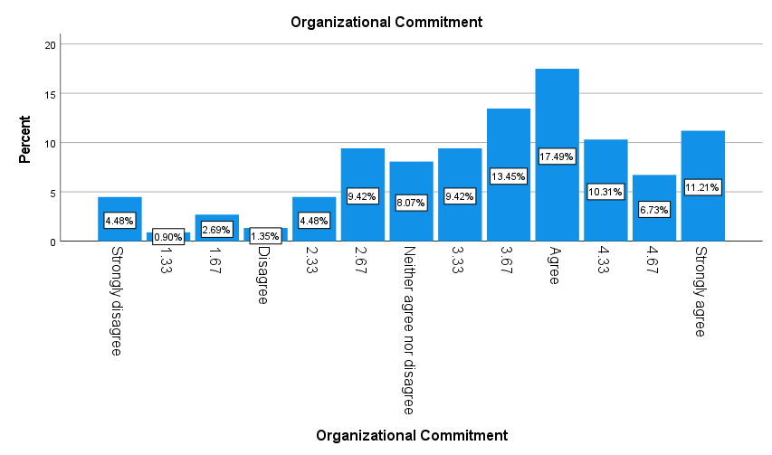

**Job Constraints:** 1.86 was the average score on the job constraints dimension, meaning most respondents found it difficult to do their job due to constraints ‘less than one per month or never’. Looking at the graph below, it is clear the majority of respondents indicated less than once per month, leaving a small minority past ‘once or twice per month’. (For clarification, 1=Less than once per month or never, 2=Once or twice per month, 3=Once or twice per week, 4=Once or twice per day, 5=Several times per day).

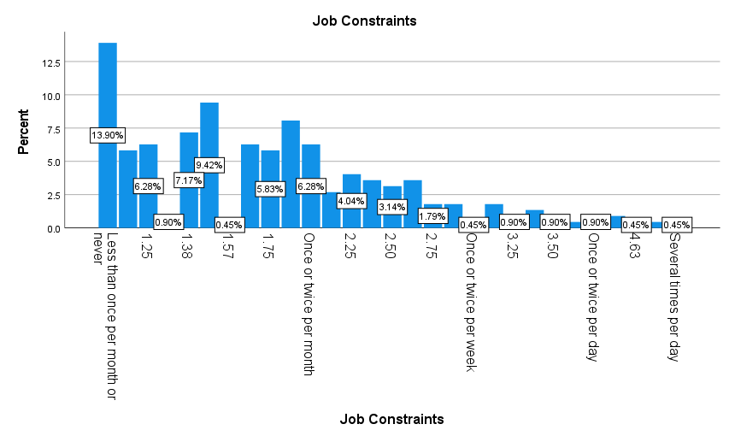

**Emotional Engagement:** Respondents indicated they agreed with the statement about feeling energetic at their job. The average/mean was 4.04, with a Standard deviation of .72. Following the average of 4, the second highest score would be strongly agreeing with the statement (4.17-5). (For clarification, 1=Strongly Disagree, 2=Disagree, 3=Neither Agree nor Disagree, 4=Agree, and 5=Strongly Agree.)

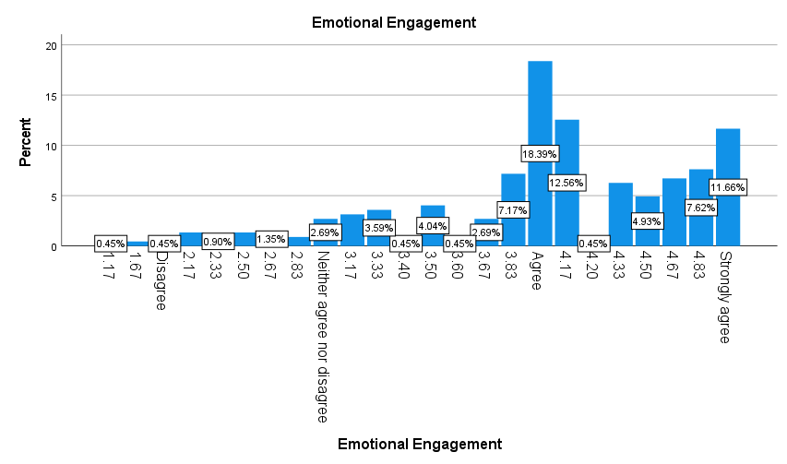

**Emotional Exhaustion (Burnout):** The majority of respondents indicated they disagree with the statement about feeling tired when they wake up in the morning having to face another day at work. The average score in this dimension was 2.58, with a standard deviation of .94, meaning scores differed almost a whole point from the average. (For clarification, 1=Strongly Disagree, 2=Disagree, 3=Neither Agree nor Disagree, 4=Agree, and 5=Strongly Agree.)

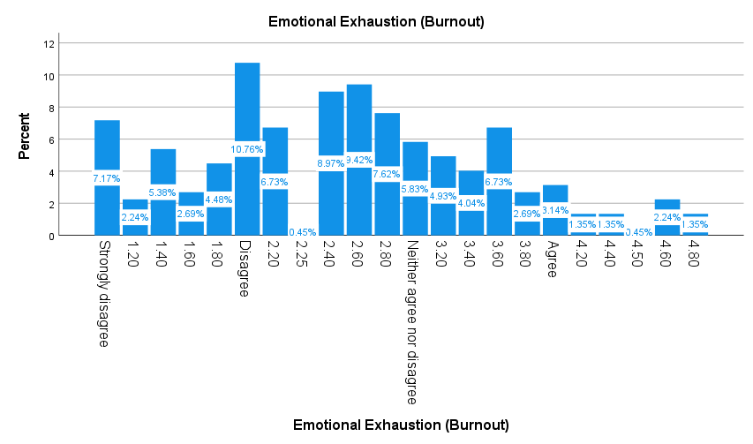

**Abusive Supervision:** Respondents indicated that their supervisors give employees the silent treatment ‘once or twice per month’. The average score of respondents was 2.14 with scores differing from the mean by .73 (standard deviation). (For clarification, 1=Less than once per month or never, 2=Once or twice per month, 3=Once or twice per week, 4=Once or twice per day, 5=Several times per day).

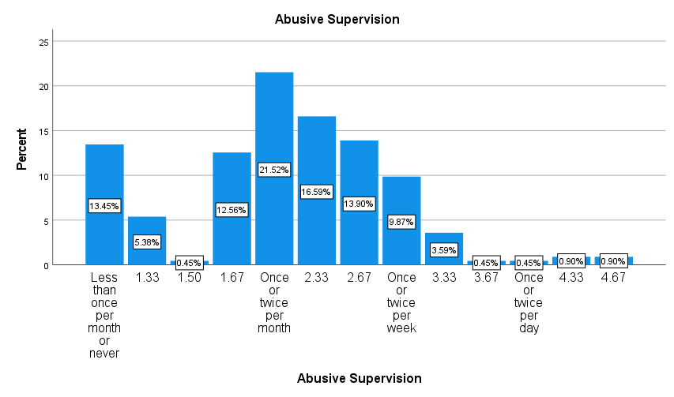

**Incivility (Climate)**: The average score for this dimension was 1.87, meaning respondents felt their colleagues or supervisor ignored or excluded them from professional camaraderie ‘none of the time’, while somewhat leaning towards rarely. The graph below coincides with this trend, showing that the average was ‘none of the time’ with ‘rarely’ in a distant second place. (For clarification, 1=None of the time, 2=Rarely, 3=Sometimes, 4-Often, 5=All of the time.)

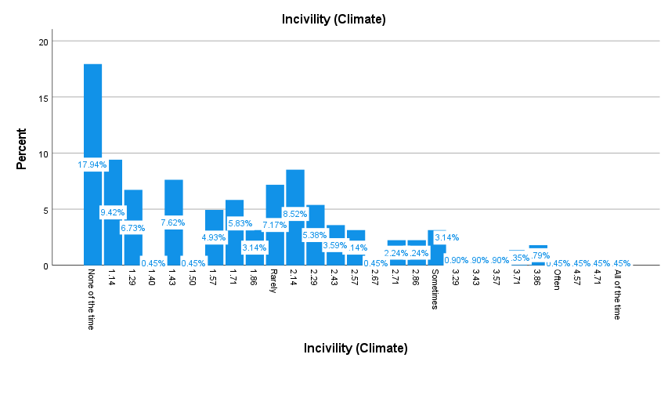

**Job Satisfaction:** Respondents neither agreed nor disagreed with the statement “All in all, I am satisfied with my job”, shown with the average score being 3.30. (For clarification, 1=Strongly Disagree, 2=Disagree, 3=Neither Agree nor Disagree, 4=Agree, and 5=Strongly Agree.) The standard deviation was .95, meaning scores deviated from the mean by almost a whole point, showing a higher spread than other dimensions. The graph below illustrates said spread:

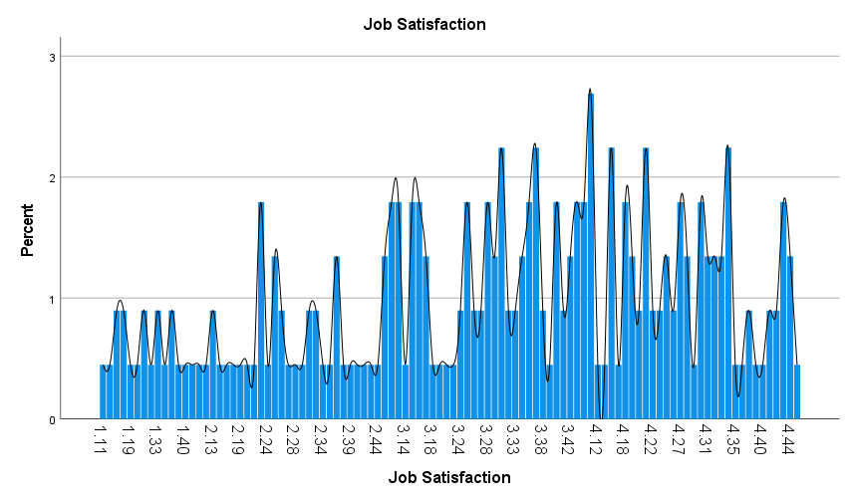

## Comparisons Between Variables (Internal Benchmarking)

After comparing the means of dimensions to key demographic variables, departments came up with the greatest differences within subgroups. These differences then match correlations between variables between Emotional Engagement and Organizational Commitment and between Incivility and Job constraints. All of which is described below.

**Differences Between Departments:** Starting with ***Organizational Commitment***, Human Resources (HR) is the lowest in this dimension, being 2.38. Compared to the highest department shipping & Distribution at 3.95, both HR and Marketing (2.50) have substantially lower percentages. ***Job Constraints*** is the highest in Marketing (3.84) by a high margin, followed by HR at 2.23, leaving the other two subgroups at lows of 1.47 and 1.74. ***Emotional Engagement*** is also the lowest in HR and Marketing, with lows of 3.15 and 3.16, compared to the others who are in the 4’s or higher. ***Emotional Exhaustion*** is the worst in Marketing and HR with highs of 3.91 and 3.57, compared to the others who are in the 2’s or higher. ***Abusive Supervision*** is a consistent 2 to 2.11 from Billing & sales to shipping & distribution, again following the trend with HR and Marketing having the worst scores of 2.48 and 2.74. ***Incivility*** is the highest by far in Marketing at 3.55, then followed by HR at 2.40 and the rest being under 2. Lastly, ***Job Satisfaction*** is the highest in Billing and sales (3.67), with the worst in Marketing at 2.51 followed closely by HR at 2.57.

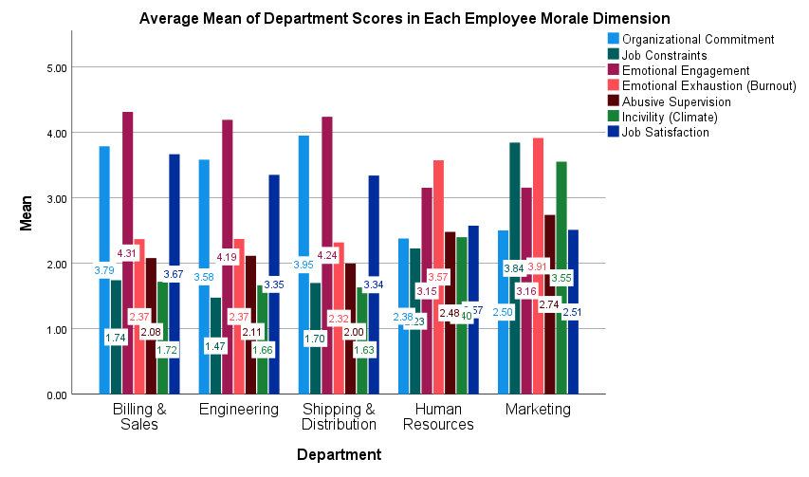

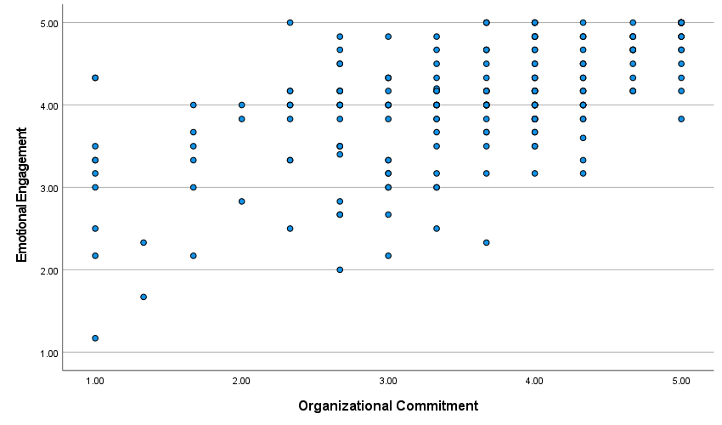**Correlations Between Variables:** For the positive correlations,there was a moderate correlation between Emotional Engagement and Organizational Commitment (.611). Meaning those who are emotionally engaged are more likely to have organizational commitment. The highest correlation would be between Incivility and Job constraints at .647. For negative correlations, there was one negative moderate correlation between Emotional Exhaustion (Burnout) and Emotional Engagement at -.605. Meaning this relationship may or may not represent causation between the two variables. (Piecewise correlations were done for each.)

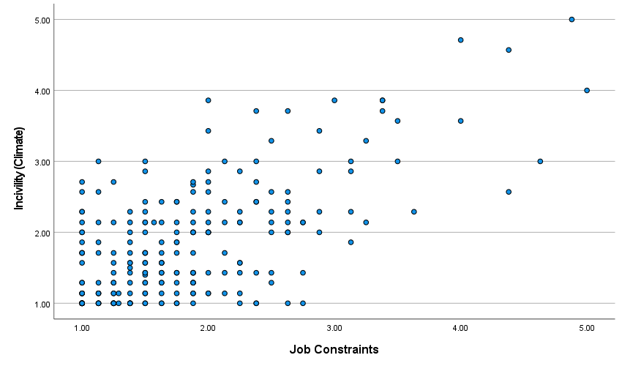

--

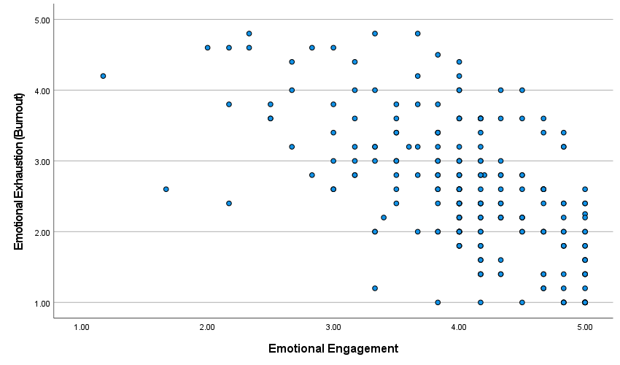

# Takeaways & Suggestions

* The best variable score for employee morale at PollyVC was Emotional Engagement
* The Variable that needs the most work for employee morale at PollyVC would be Job Satisfaction
* Billing & Sales, Engineering, and Shipping & Distribution have the highest overall employee morale.
* Action is needed in Human Recourses and Marketing to increase employee morale
* To fix the problems within HR and Marketing, there should be a greater focus on showing camaraderie and respect to anyone within the organization, an ease on some organizational rules and procedures to alleviate job constraints, and an assistance with workload or time limits to decrease Emotional Exhaustion (Burnout). After doing all of this I believe the overall job satisfaction of each department will increase, therefore improving the general employee morale of PollyVC